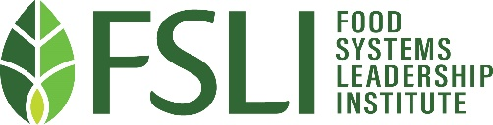
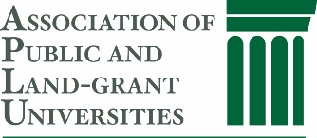

APLU Food Systems Leadership Award
Presented by the Association of Public Land-grant Universities

Purpose:
The Association for Public Land-grant Universities (APLU) Food Systems Leadership Award recognizes senior leaders who have made an extraordinary impact on the food system through leadership and service and who exemplify the core principles established by the Food Systems Leadership Institute (FSLI), including personal leadership, organizational leadership, and food systems leadership. The award also recognizes the leadership, innovation, engagement, and service that APLU promotes through its programs.

Background:
APLU’s FSLI program was created in 2004 with a five-year seed grant from the W.K. Kellogg Foundation to advance and strengthen leadership in the food system by enhancing leaders’ development and increasing their influence for institutional change. A design team was formed with the charge to shape a leadership development program for higher education, industry, and governmental leaders that would prepare the next generation of food systems leaders. This transformation of the food systems culture, particularly within land-grant universities, would require “a cadre of new leaders to create and recreate the food systems of the future.” The FSLI has made and will continue to make a difference in ensuring that the pipeline is filled with highly competent leaders who appreciate strong food systems in our land-grant system. Recognized throughout all the cohorts are FSLI fellows who are moving into spheres of influence within land-grant universities, industry, and government: over 30% of all the FSLI Fellows have taken on higher-level responsibilities and influence.

Award Criteria:

A nominee must:
- Be a leader in higher education, industry, or government who has impacted the food system
- Exemplify the Core Principles established by FSLI that include:
  - articulating a broad, integrated food systems perspective focused on healthy humans, environments, communities, and/or economies
  - engaging diverse constituencies to focus on major food system challenges, issues, and opportunities
  - influencing values, goals, and strategic directions related to food systems
  - advocating for change within the food system

Process:
Each year, a call for nominations will be sent from APLU to appropriate groups who work on issues related to the food system. Brief nominations from these groups and nominations submitted by the FSLI Commission will create the candidate pool for the award. An Award Review committee of FSLI Commission members will evaluate the nominations and select the most outstanding nominees for which additional material will be requested in support of the nominee. The FSLI Commission will select one recipient of the award each year. The award will be given at the awards program at the APLU Annual Meeting, usually held in November. The recipient(s) will be invited to address the current cohort of FSLI Fellows during one of the cohort's virtual webinars.

