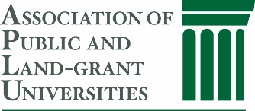

APLU Food Systems Leadership Award
Nomination Form

Date __________________

Nominee Information
Name _____________________________________________________________________
Title ___________________________________ Organization_____________________________
Address____________________________________________________________________
Phone________________ Email Address _________________________________________

Nominator Information
Name ____________________________________________________________________
Title __________________________________
Organization _________________________
Address____________________________________________________________________
Phone_________________ E-mail Address ________________________________________

Additional References Who Might Be Contacted to Provide Supporting Material on the Nominee:

Name_____________________________________________________________________
Title _________________________________
Organization__________________________
Address___________________________________________________________________
Phone_________________ E-mail Address _______________________________________

Name ____________________________________________________________________
Title __________________________________
Organization ___________________________
Phone_________________ E-mail Address _______________________________________

Nominations Due: February 27, 2026
To gain an understanding of the caliber of individuals who are competitive for this award, please visit the FSLI website. http://fsli.org/leadership-awards.html

Submission Materials: Completed Nomination Form and curriculum vitae of the nominee. No additional information will be considered.

The FSLI Commission’s Award Committee will review nominations and select one or more for which additional supporting materials may be requested. The nominator may be asked to provide additional material and to request materials from others familiar with the nominee’s accomplishments. Award recipients will be selected from those for whom supporting materials are received.

Submit the Nomination Form to:
Food Systems Leadership Institute
Attention: Dr. Sarah Kotzian, Program Manager
Phone: 919-515-4197
sehardis@ncsu.edu

