The Psychology of Critical Thinking

How Critical Thinking is an everyday survival skill!
Claudia Fernandez, DrPH, MS, RD, LDN
University of North Carolina, Chapel Hill
Critical Thinking is a self-directed process
by which we take deliberate steps
to think at the highest level of quality.

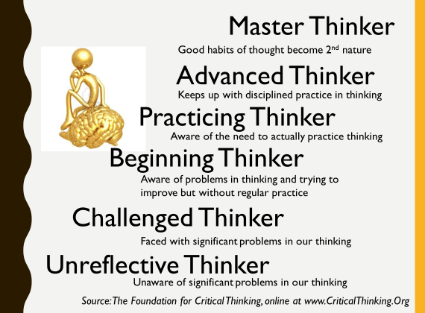
Standards of Reasoning and Questions
Test for: | By asking this:
CLARITY | Can you give me an example?  Can you elaborate?  Could you illustrate what you mean?
ACCURACY | How could we check on that?  How could we verify that?
PRECISION | Could you be more precise?  Could you give me more details?
DEPTH | What factors make this a difficult problem?  What are some of the difficulties we need to deal with?
LOGIC | Does all this make sense together?  Does your first paragraph fit in with your last?  Does what you say follow from the evidence?
RELEVANCE | How does that help us with the issue?  Hoes does that relate to the problem?
FAIRNESS | Am I sympathetically representing the viewpoints of others?  Do I have a vested interest in this issue?
SIGNIFICANCE | Is this the most important problem to consider?  Which of these facts are most important?  Is this the central idea to focus on?
BREADTH | Do we need to look at this from another perspective?  Do we need to look at this in other ways?

Egocentric Thinking
Innate Ego-centrism | “It’s true because I believe it”
Innate Socio-centrism | “It’s true because WE believe it”
Innate Wish Fulfilment | “It’s true because I want to believe it”
Innate Self-Validation | “It’s true because I have always believed it”
Innate Selfishness | “It’s true because it’s in my selfish interest to believe it”

